

Assignment 01

Submitted By Ijlal Ahmad
Submitted To DR. Jaweria Kanwal
Roll No FL-21565
Date 12-05-2025
Subject SCD

- Requirement Specification Document:

- Functional Requirements

1. User Management

Add New User (Librarian/Student/Member)
- Purpose: Register new users (librarians, students, or members) into the system.
- Details:
  - Collect details like name, ID, contact info, and role.
  - Assign a unique User ID for identification.
  - Store user data in a database.

1.2 Edit/Update User Information
- Purpose: Modify existing user details (e.g., phone number, address).
- Details:
  - Search for a user by ID or name.
  - Allow updates to personal information.

1.3 Delete User
- Purpose: Remove a user from the system (e.g., if they leave the institution).
- Details:
  - Search for the user and confirm deletion.
  - Ensure no active book loans before deletion.

1.4 View User Details
- Purpose: Display user information for administrative purposes.
- Details:
  - Search by ID, name, or role.
  - Show borrowing history if applicable.

2. Book Management

2.1 Add New Book
- Purpose: Enter a new book into the library database.
- Details:
  - Input title, author, ISBN, genre, publication year, and quantity.
  - Assign a unique Book ID.

2.2 Update Book Information
- Purpose: Modify book details (e.g., change quantity, correct author name).
- Details:
  - Search by title, ISBN, or Book ID.
  - Allow editing of book metadata.

2.3 Remove Book
- Purpose: Delete a book from the system (e.g., if lost or damaged).
- Details:
  - Ensure no active loans before removal.
  - Log deletion for records.

2.4 Search Books
- Purpose: Allow users to find books easily.
- Details:
  - Search by title, author, ISBN, or genre.
  - Display availability status (Available/Borrowed).

3. Borrowing & Returning System

3.1 Issue Book (Check-out)
- Purpose: Allow users to borrow books.
- Details:
  - Verify user eligibility (no overdue books).
  - Record check-out date and due date.
  - Update book status to "Borrowed".

3.2 Return Book
- Purpose: Process book returns.
- Details:
  - Scan Book ID or enter manually.
  - Check for late returns and apply fines if needed.
  - Update book status to "Available".

3.3 Renew Book
- Purpose: Extend borrowing period if no reservations exist.
- Details:
  - Check if renewal is allowed (max renewals = 1 or 2).
  - Update due date.

3.4 Track Overdue Books
- Purpose: Identify late returns and manage penalties.
- Details:
  - Automatically flag overdue books.
  - Calculate fines (e.g., $1 per day late).
  - Send reminders via email (if implemented).

4. Reporting & Analytics

4.1 Generate Borrowing Reports
- Purpose: Track book circulation trends.
- Details:
  - Show most borrowed books.
  - Filter by date range, genre, or user type.

4.2 View Fines & Payments
- Purpose: Manage late fees and payments.
- Details:
  - List users with pending fines.
  - Record payments and update balances.

4.3 Inventory Status
- Purpose: Check total books, available copies, and lost/damaged books.
- Details:
  - Display summary statistics.
  - Export data to CSV/PDF (optional).

5. Authentication & Security

5.1 Login/Logout
- Purpose: Secure access to the system.
- Details:
  - Librarians have full access.
  - Members can only view/borrow books.

5.2 Password Reset
- Purpose: Allow users to recover accounts.
- Details:
  - Email verification or security questions.

Non-Functional Requirements
- Performance:
  - System should handle 100+ concurrent users.
  - Search results should load in <2 seconds.

- Security:
  - Passwords must be encrypted.
  - Unauthorized users cannot modify data.

- Usability:
  - Simple, intuitive interface.
  - Mobile-friendly (optional).

- Detailed Design Document:
- Use-case diagram:
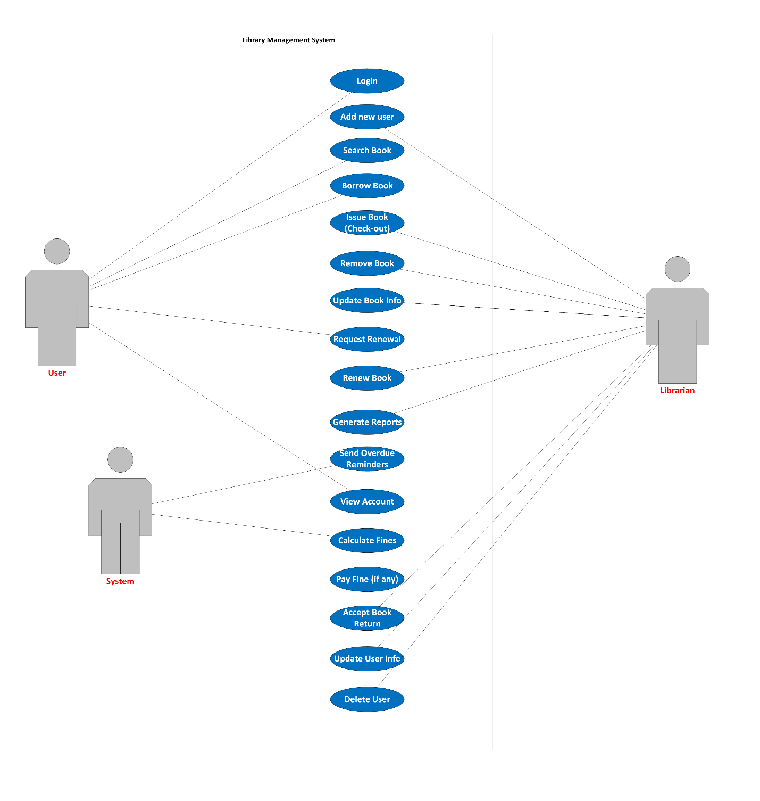

- Object diagram:
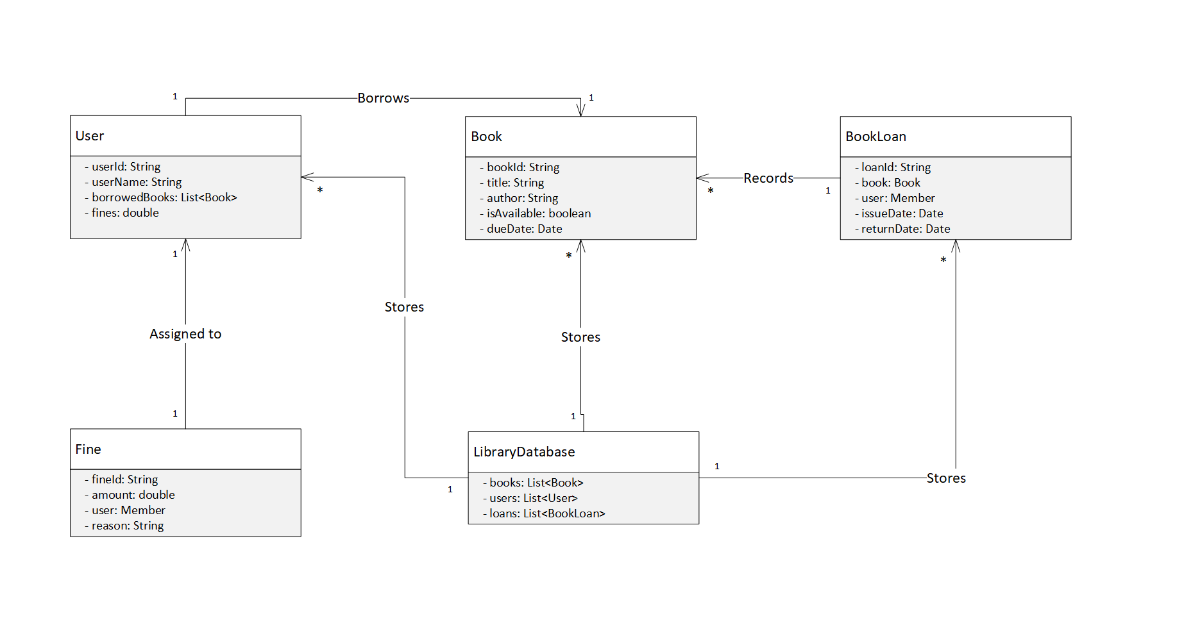

- Sequence diagram:
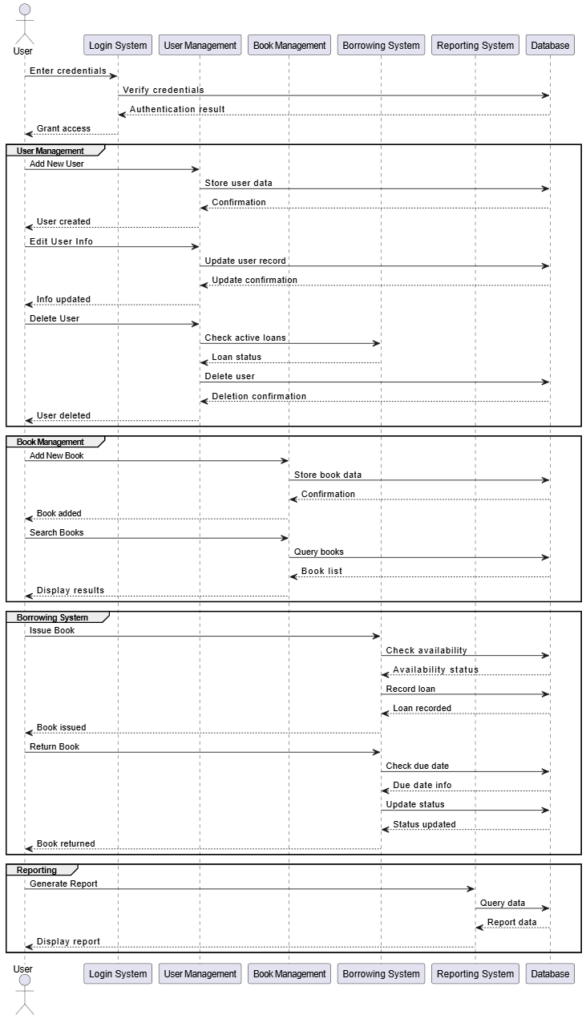
- Communication diagram:

